Due to the emergence of covid pandemic and closing down of all educational institutions as per Government guidelines, it was not possible to organize any event with physical presence. Therefore as an alternative way, ten webinars were organized by different academic departments as advised by IQAC. The details of the webinars are given below.
National Webinar on Cloud Computing and its impact on Library Services
Date: 15- 17 May, 2020 Time: 3.00 to 5.00 pm
Organiser | Resource person(s)
Naharkatiya College | Dr. Sanjay Kumar Singh, Professor and Head, Department of Library and Information Science, Gauhati University, Guwahati, Assam.  Dr. S. Ravikumar, Asst. Professor, Department of Library and Information Science, North Eastern Hill University, Shillong: Assam.  Dhanwantari Prakash Tripathi, Assistant Librarian, National Institute of Technology, Rourkela, Sundargarh, Odisha, India.

Coordinator: Shri Suraj Gogoi
Number of participants: 502

National Webinar on Academic and Research Integrity
Date: 27 & 28 May, 2020 Time: 2.30 to 5.00 pm
Organiser | Resource person(s)
Naharkatiya College | Prof. (Dr.) Ramesh C Gaur, Dean & Head Kala Nidhi at Indira Gandhi National Centre for the Arts, Ministry of Culture, Govt. of India.  Dr. Utpal Das, Deputy Librarian, Dibrugrah University, Dibrugrah : Assam.  Dr. S. Ravikumar, Assistant Professor, Department of Library & Information Science, North Eastern Hill University, Shillong: Meghalaya.  Dr. Tilak Hazarika, Assistant Professor, Department of Library & Information Science, Guahati University, Guwahati, Assam.

Coordinator: Shri Suraj Gogoi
Number of participants: 674
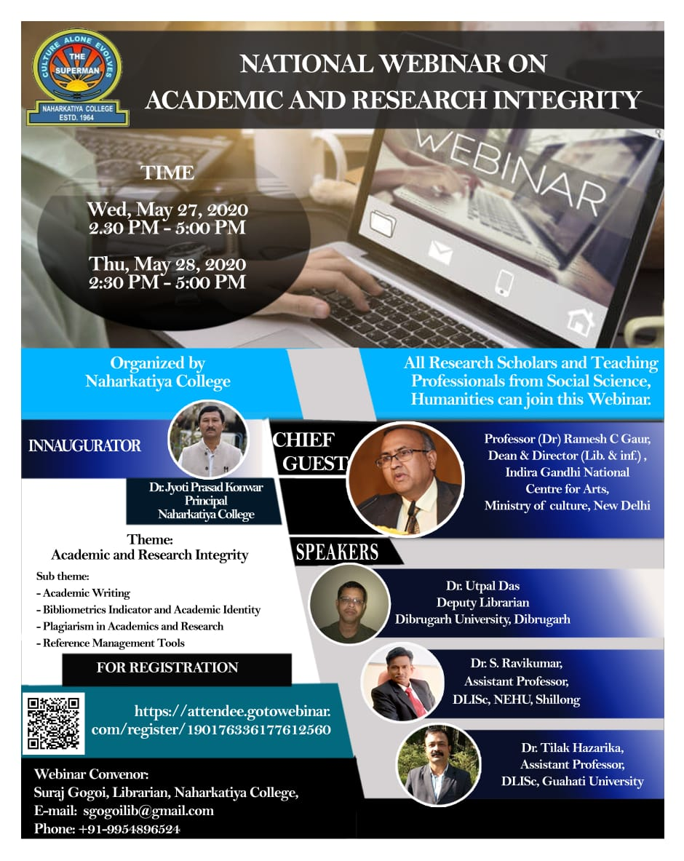
Virtual Workshop on Design and Development of Digital Repository using DSpace
Date: 30 & 31 May, 2020 Time: 2.15- 5.00 pm
Organiser | Resource person(s)
Central Library and IQAC, Naharkatiya College | Prof. Parthasarathi Mukhopadhyay, Professor (HoD), Department of Library & Information Science , Kalyani University, Kolkata: West Bengal.  Sher Afzal Khan, President Koha Pakistan, Lead Consultant, HEC approved trainer for Libraries, Pioneer Country Ambassador of DSpace MIT USA.  Dr. Dipen Deka, Assistant Professor, Department of Library & Information Science, Guahati University, Guwahati, Assam.  Dr. Gautam Kumar Sarma, Assistant Librarian, Krishna Kanta Handiqui State Open University, Guwahati, Assam

Coordinator: Shri Suraj Gogoi
Number of participants: 424
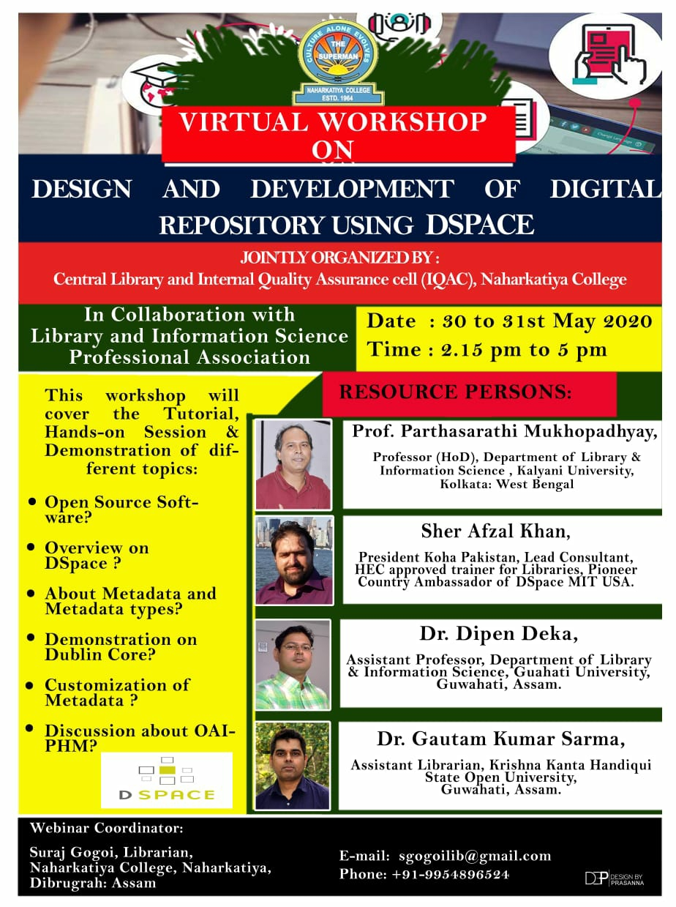
Virtual Orientation Programme on Electronic Resources and E-learning Platform
Date: 08/06/2020 Time: 11 am – 12.30 pm
Organiser | Resource person(s)
Central Library,  Naharkatiya College | Dr. Pranab Kumar Barooah, Professor, DLISc, University of Science Technology and Management, Meghalaya  Sri Hirak Jyoti Hazarika, Research Scholar, DLISc, North Eastern Hill University, Shillong

Coordinator: Shri Suraj Gogoi
Number of participants: 397
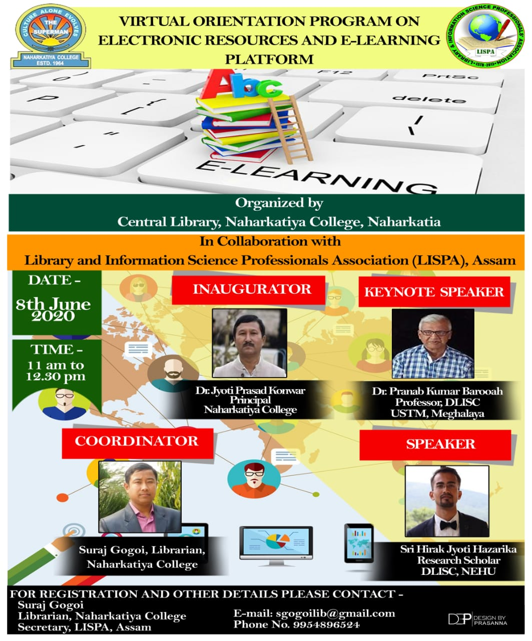

Career Opportunities in English Language and Literature
Date: 27/06/2020 Time: 11am-12 pm
Organiser | Resource person(s)
Dept. of English,  Naharkatiya College | Nabanita Hazarika, Assistant Professor, Dept. of Language Studies (English), Assam Don Bosco University, Guwahati

Coordinator: Mrs. Karabi Hazarika
Number of participants: 150
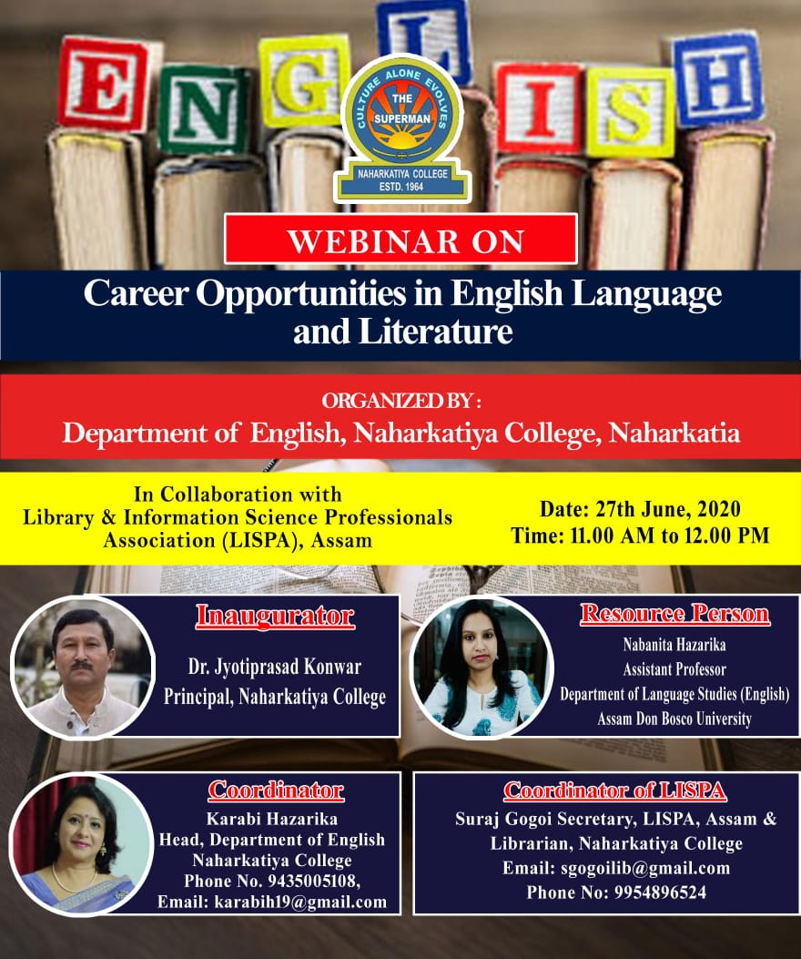

Behavioural Finance: A Curtain Raiser
Date: 30/06/2020 Time: 11 am-12 pm
Organiser | Resource person(s)
Dept. of Commerce,  Naharkatiya College | Prof. Amalesh Bhowal, Dept. of Commerce, Assam University (Diphu Campus), Diphu

Coordinator: Dr. Amlan Jyoti Sharma
Number of participants: 116
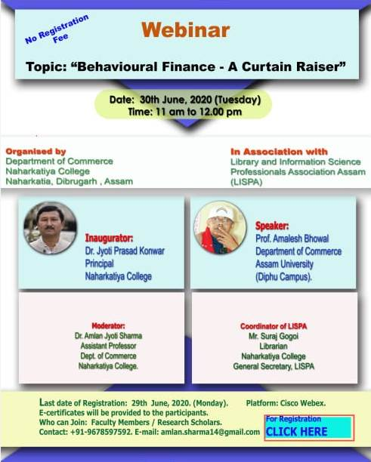
Importance of Mental Health of the Students for Leading a Well-balanced Life
Date: 02/07/2020 Time: 11 am
Organiser | Resource person(s)
Dept. of Education,  Naharkatiya College | Dr. Indrani Kalita, Asst. Professor, Dept. of Education, Krishna Kanta Handique State Open University, Guwahati

Coordinator: Dr. Anita Mahanta
Number of participants: 397

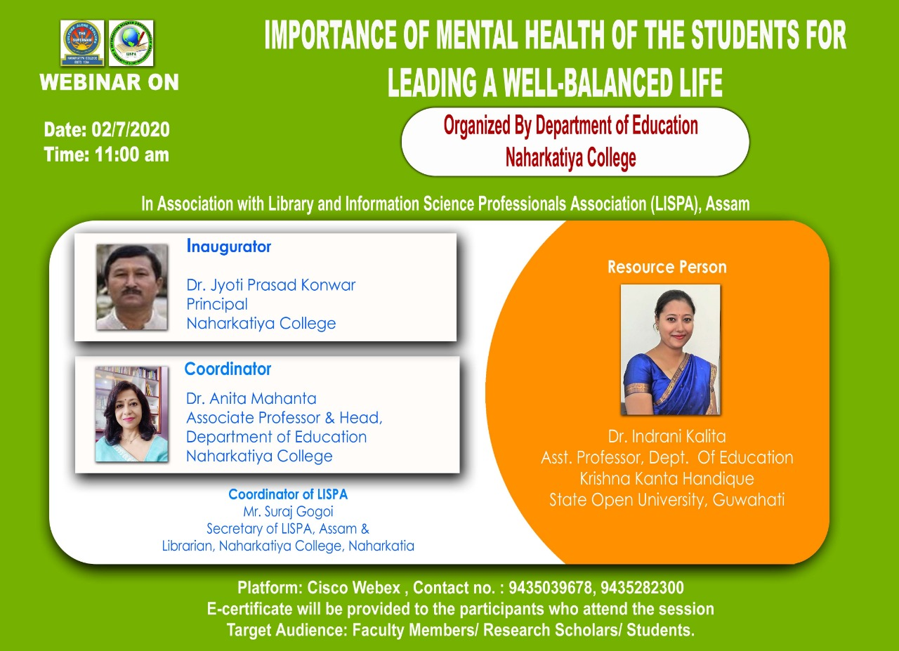
Indo-Chinese Relations: Co-operation and Conflict in Historical Perspective
02/07/2020 Time:3 pm
Organiser | Resource person(s)
Dept. of History & Dept. of Political Science,  Naharkatiya College | Prof. Biswajeet Baruah, Dept. of History & Dean, School of Social Sciences, Dibrugarh University, Dibrugarh

Coordinator: Dr. Ananta Baruah & Nilam Hazarika
Number of participants: 112

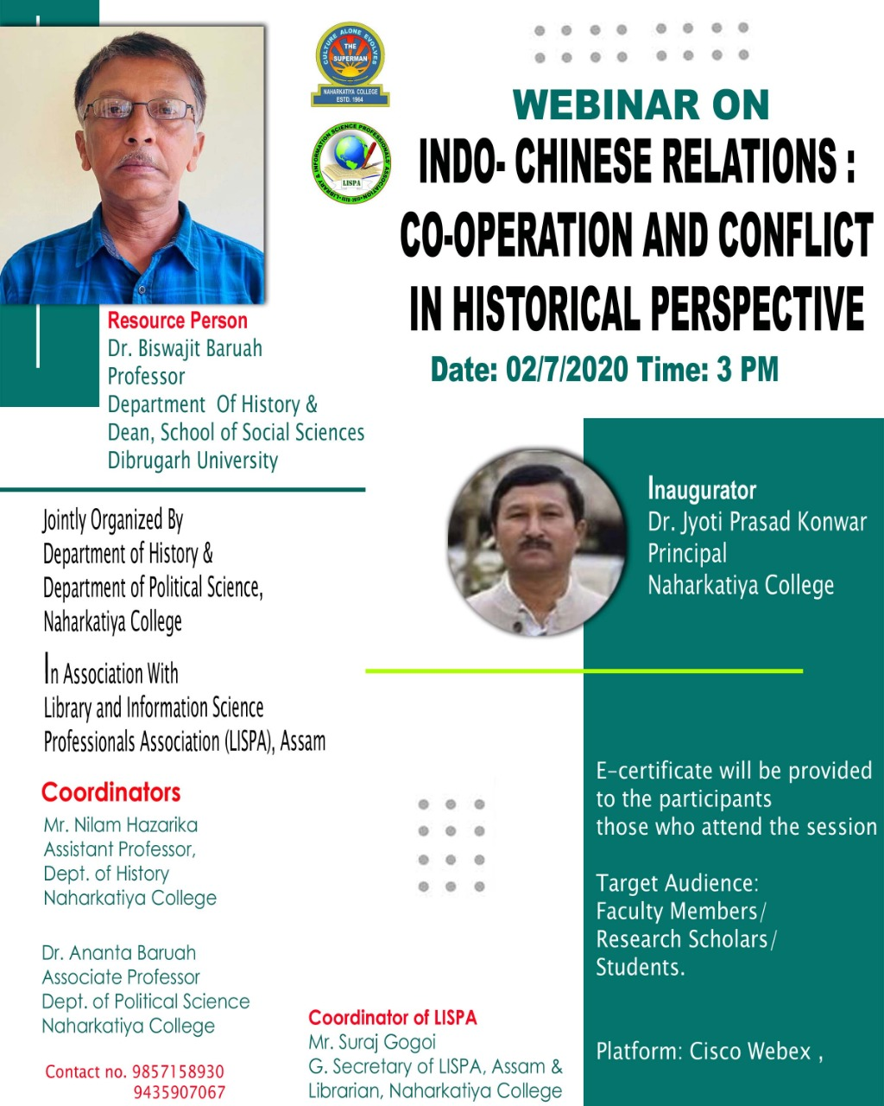
বৈদ্যুতিন মাধ্যমত পৰিৱেশিত বাতৰি আৰু বিজ্ঞাপনৰ ভাষাশৈলী
06/07/2020 Time: 11 am-12.30 pm
Organiser | Resource person(s)
Dept. of Assamese,  Naharkatiya College | Dr. Satyakam Borthakur, Dept. of Assamese & Chairperson, CSJMC, Dibrugarh University, Dibrugarh  Dibyajyoti Sarmah, Asst. Prof., Centre for Studies in Journalism and Mass Communication, Dibrugarh University, Dibrugarh

Coordinator: Dr. Smrity Rekha Gogoi Gayan
Number of participants: 268
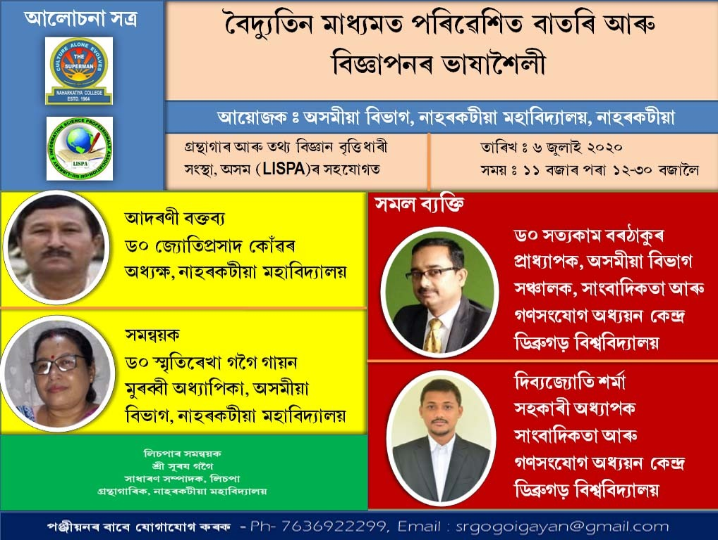
Indian Economy and Covid-19 Pandemic
17/07/2020 Time:11 am-12 pm
Organiser | Resource person(s)
Dept. of Economics,  Naharkatiya College | Dr. Amarjyoti Mahanta, Head & Associate Prof., Dept. of Economics, Dibrugarh University, Dibrugarh

Coordinator: Mr. Diganta Tamuli
Number of participants: 160
